# Artificial Intelligence and Machine Learning Assignment

#### 宋浩宇

#### Haoyu Song

#### 202300130183

Part A

1. Traditionally, the decision-making for crop cultivation is based on experience, and the assessment of crop growth status is often vague, which usually cannot maintain the optimal growth state of crops. Therefore, machine learning models can be used to classify the growth status of crops and provide guidance, taking grape cultivation as an example, thus leading to an image classification-based grape cultivation guidance model.
2. To solve this problem using machine learning techniques, one can first collect images of grapes in various growth states (excessive or insufficient water; lack of nitrogen, phosphorus, or potassium; insufficient or excessive light; high or low environmental temperature, etc.), and then build a convolutional neural network (CNN) to train the model, enabling it to classify the growth status of grapes in the images.
3. Supervised learning is the most suitable approach for this problem.
4. The best algorithm to solve this problem is CNN. The reason is that CNN has a strong capability in feature recognition, which can distinguish the unique characteristics of grape plants under different environmental conditions. Moreover, the trained CNN model also has good generalization ability.
5. The expected result is: through the classification capability of the model, the images of grape plants taken by the growers can be classified, thus determining the growth status of the plants and providing guidance accordingly. Traditionally, agricultural decisions are based on experience and subjective judgment, while machine learning models can accurately classify the growth status of grapes based on data, such as over-watering, nutrient deficiency, and environmental adaptation. This will help growers better understand the health status and needs of each grape plant. The image classification model can also enable real-time monitoring and evaluation of the grape orchard, allowing timely detection of issues and the adoption of appropriate measures. For example, when the model detects a lack of a specific nutrient in some grape plants, the grower can immediately adjust the fertilization strategy to maximize yield and quality. Accurate growth status identification also helps optimize the use of resources, including water, fertilizers, and labor, which not only reduces costs but also promotes environmental sustainability. Furthermore, the decision support provided by the machine learning model is data-driven, which has higher scientific validity and reproducibility compared to traditional methods. This means that different growers can make similar decisions in similar situations, improving overall management level and efficiency. Additionally, the long-term accumulation of the model's effects will make grape cultivation management increasingly intelligent and reliable as more data and experience are accumulated over time.

Part B

The training task type is pattern recognition and the dataset used is the default dataset Iris Flowers in matlab nprtool.

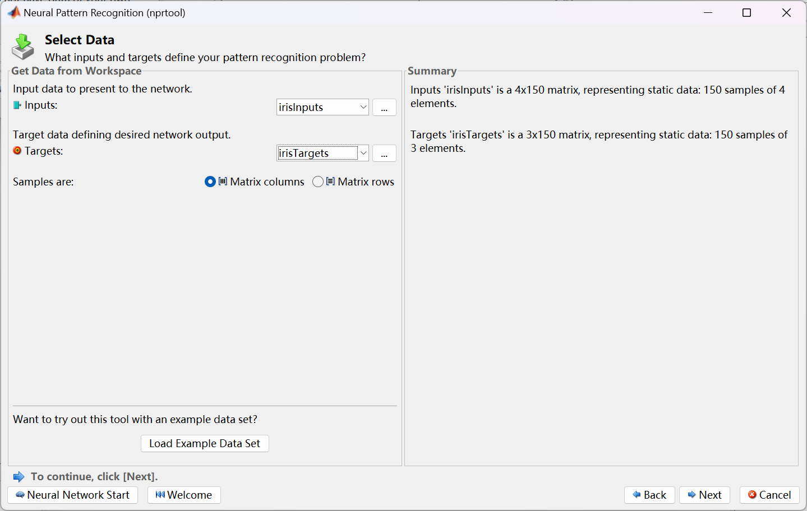

Validation is set to 10% and Testing is also set to 10%.

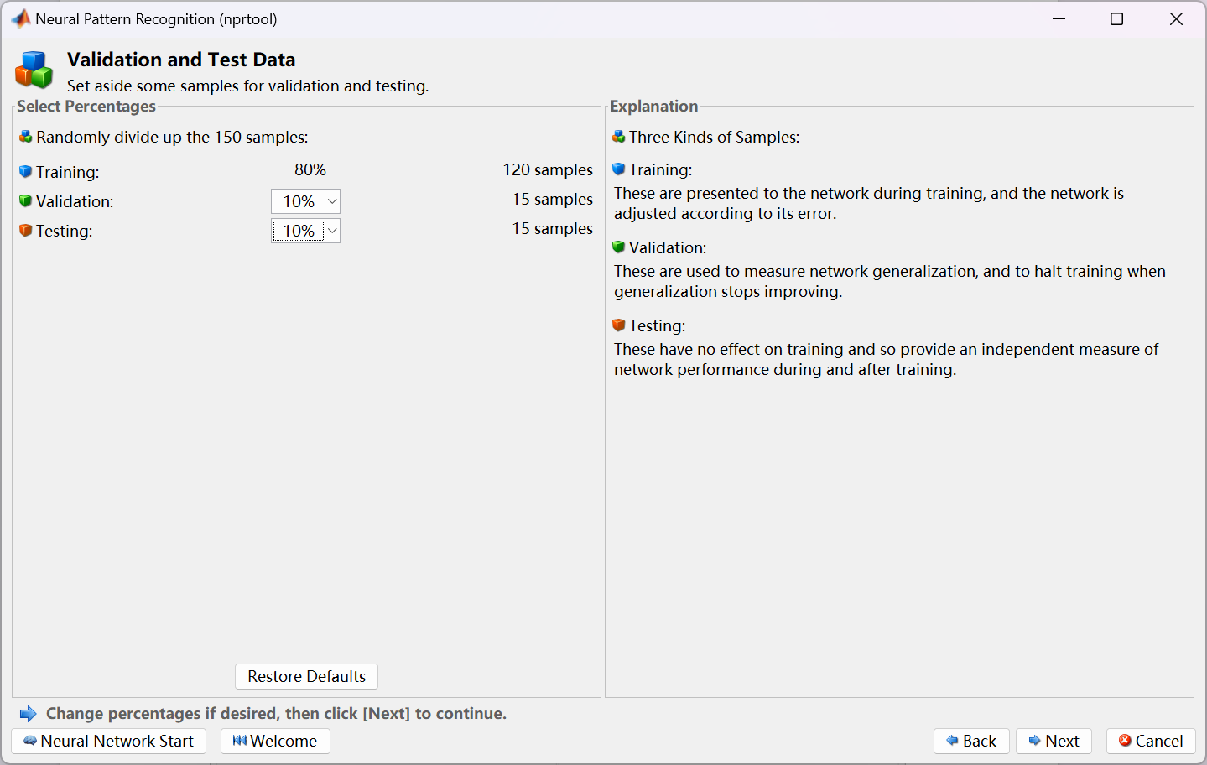

The hidden layers of the neural network were set to 12 layers.

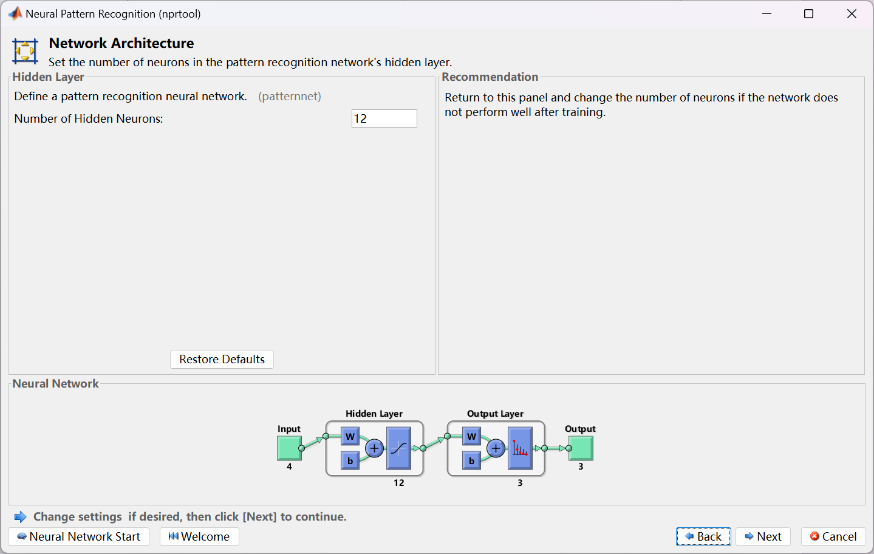

After setting up the training, because the amount of data is very small, so you can retrain several times to get better results, the following is the result of the last retrain.

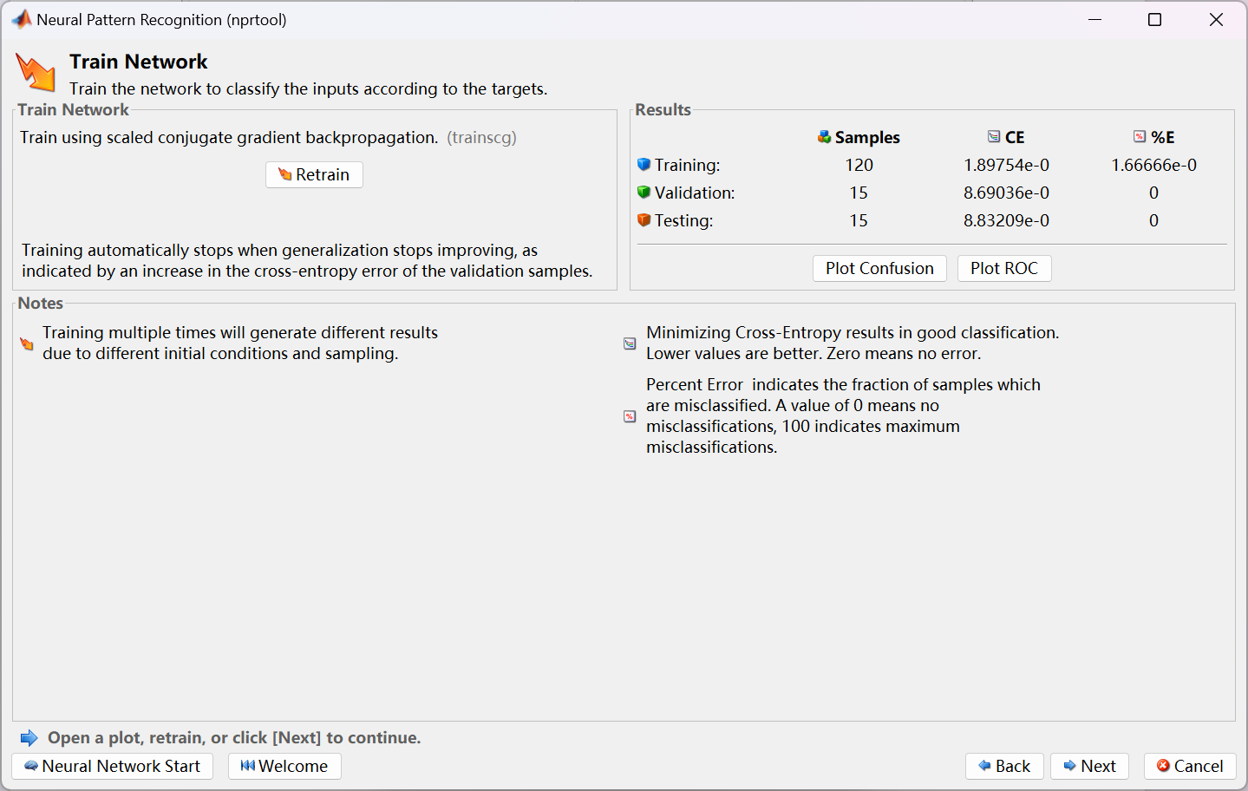  
The graphs of the various performances of the neural network are given below:

Performance

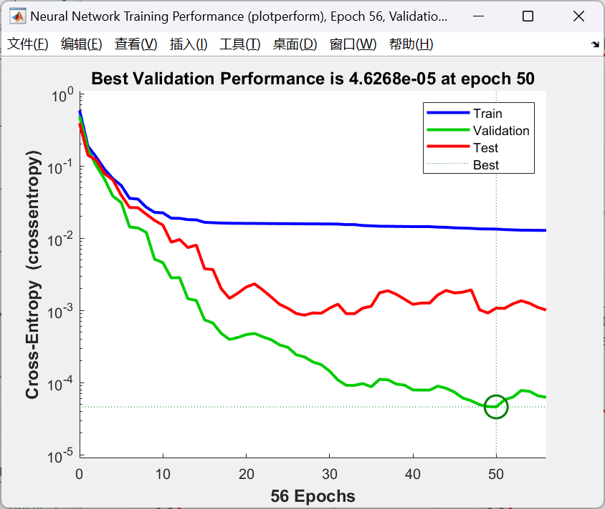

Training State

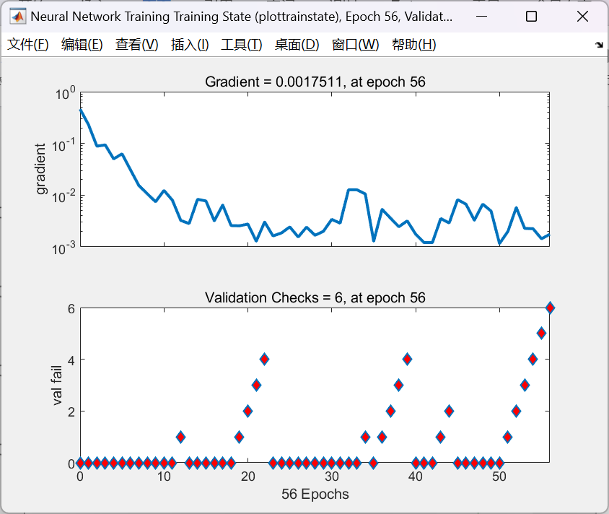

Error Histogram

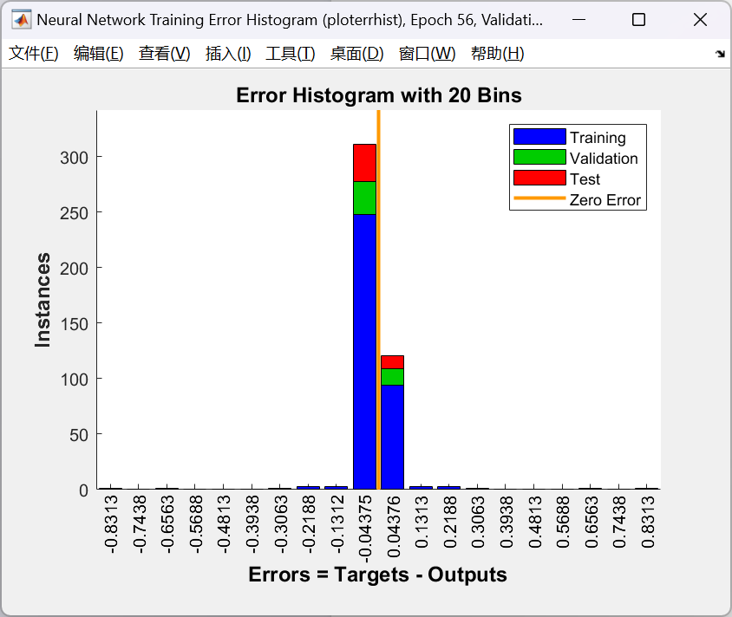

Confusion

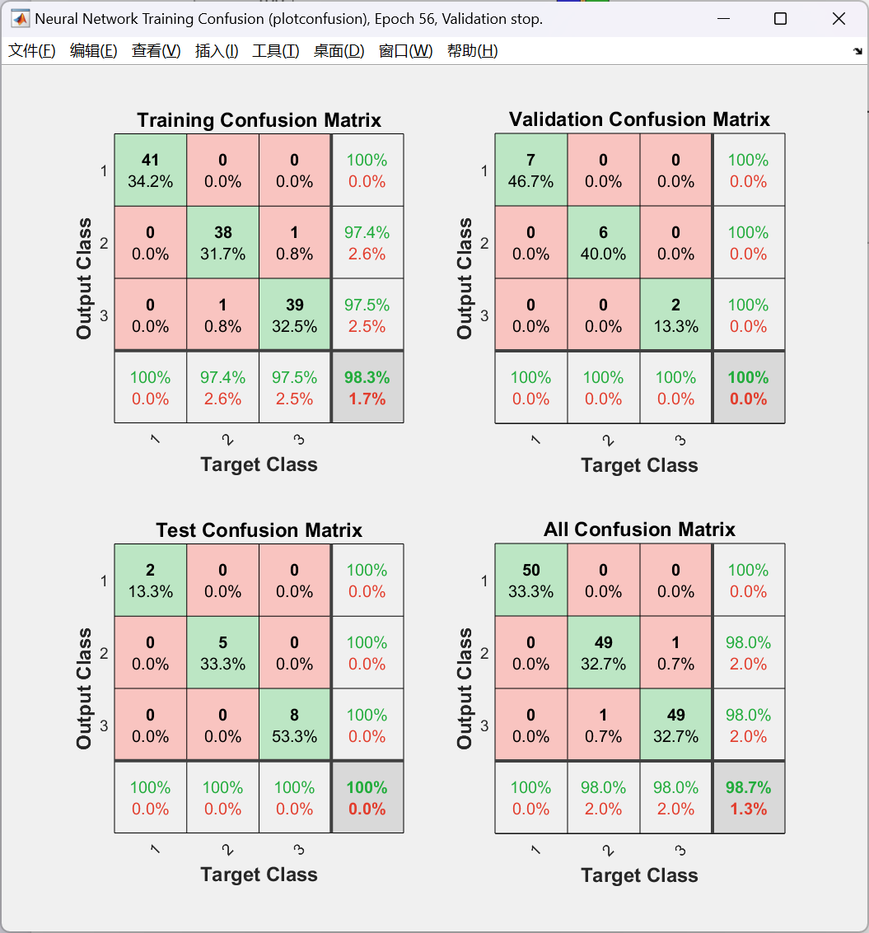

ROC

